Program 2: Working with Maven: Creating a Maven Project, Understanding the POM File, Dependency Management and Plugins

Step 1: To create a Maven project run the following command in terminal:

mvn archetype:generate -DgroupId=com.example -DartifactId=MyMavenApp - DarchetypeArtifactId=maven-archetype-quickstart -DinteractiveMode=false
This command generates a basic Maven project structure with a sample App.java and AppTest.java.
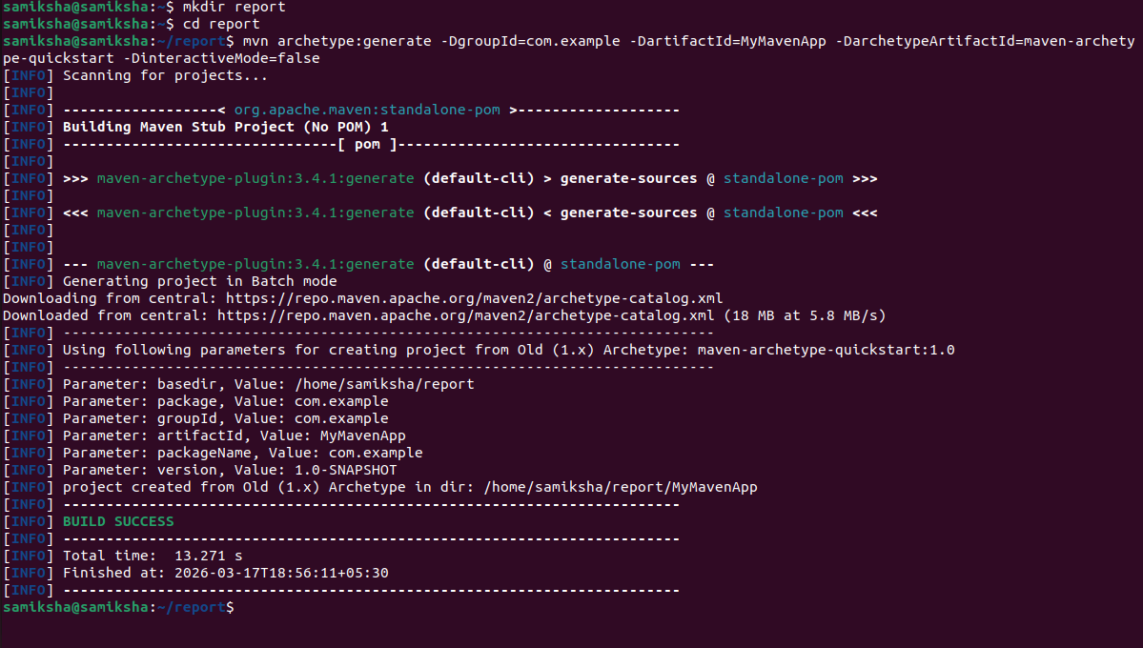
This “BUILD SUCCESS” will confirm that the project is created successfully
Step 2: Go to the project directory using command cd MyMavenApp
Step 3: Open and edit pom.xml file using command gedit pom.xml
- Go to https://mvnrepository.com
- Search for a dependency “junit”
- Select the latest version and copy the dependency XML snippet.
- Paste it under the <dependencies> section in pom.xml
- Updated pom.xml:
<project xmlns="http://maven.apache.org/POM/4.0.0" xmlns:xsi="http://www.w3.org/2001/XMLSchema-instance" xsi:schemaLocation="http://maven.apache.org/POM/4.0.0
http://maven.apache.org/maven-v4_0_0.xsd">
<modelVersion>4.0.0</modelVersion>
<groupId>com.example</groupId>
<artifactId>MyMavenApp</artifactId>
<version>1.0-SNAPSHOT</version>
<packaging>jar</packaging>
<name>MyMavenApp</name>
<url>http://maven.apache.org</url>
<!-- Java version configuration -->
<properties>
<maven.compiler.source>11</maven.compiler.source>
<maven.compiler.target>11</maven.compiler.target>
</properties>
<!-- Dependencies -->
<dependencies>
<dependency>
<groupId>junit</groupId>
<artifactId>junit</artifactId>
<version>3.8.1</version>
<scope>test</scope>
</dependency>
</dependencies>
<!-- Build Plugins -->
<build>
<plugins>
<!-- Compiler Plugin -->
<plugin>
<groupId>org.apache.maven.plugins</groupId> <artifactId>maven-compiler-plugin</artifactId>
<version>3.8.1</version>
<configuration>
<source>11</source>
<target>11</target>
</configuration>
</plugin>
<!-- Surefire Plugin for Testing -->
<plugin>
<groupId>org.apache.maven.plugins</groupId>
<artifactId>maven-surefire-plugin</artifactId>
<version>2.22.2</version>
</plugin>
<!-- JAR Plugin with Entry Point -->
<plugin>
<groupId>org.apache.maven.plugins</groupId>
<artifactId>maven-jar-plugin</artifactId>
<version>3.1.0</version>
<configuration>
<archive>
<manifestEntries>
<Main-Class>com.example.App</Main-Class>
</manifestEntries>
</archive>
</configuration>
</plugin>
</plugins>
</build>
</project>
Step 4: Build the project using command mvn clean install
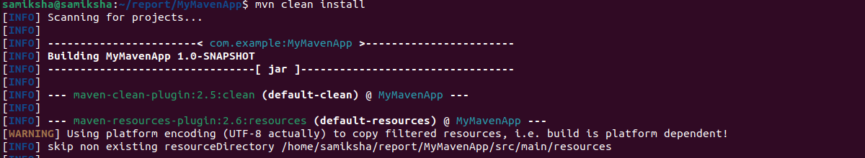
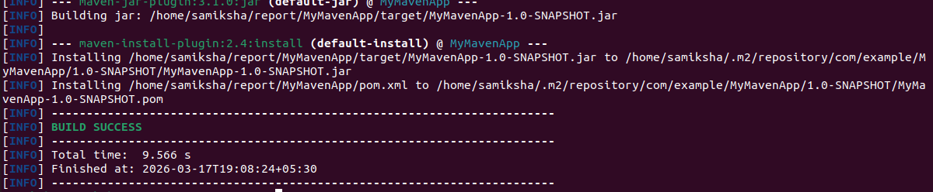

The “Build Success” message ensures that our Maven project is built successfully.
Step 5: To run the Maven application type he command:

java -jar target/MyMavenApp-1.0-SNAPSHOT.jar
● After completing the execution, the output will look like:
This will show output as the code present in App.java file we can edit the text to get any other output.

Creating a Maven Project with Guava and Commons-IO

Google Guava Dependency
Guava is a set of core libraries developed by Google to fill gaps in Java's standard libraries. It is used for:
- Collections enhancements: Multimap, BiMap, Table, ImmutableList, etc.
- Functional programming utilities: Predicates, Functions, Suppliers.
- Caching: Built-in caching mechanisms (CacheBuilder) like a mini in-memory cache.
- String utilities: Splitter, Joiner, CharMatcher.
- Concurrency: ListenableFuture, Service, and other helper classes.
- Hashing and hashing strategies: Useful for consistent hashing (e.g., Bloom filters).
Overall, Guava simplifies and improves many core Java patterns and utilities.

Apache Commons IO Dependency
Apache Commons IO is focused purely on input/output utilities, especially for file and stream handling. It is used for:
- File operations: Easily read/write files with FileUtils.
- Stream utilities: IOUtils.copy(), IOUtils.toString() — simplifies stream handling.
- Directory monitoring: FileAlterationObserver for detecting changes in a folder.
- File filtering: WildcardFileFilter, SuffixFileFilter.
Overall, Commons IO reduces boilerplate and errors when working with files or streams.
Maven Project with Guava and Commons-IO Dependencies Create a Maven Project Using Terminal by following command:

mvn archetype: generate -DgroupId=com.example -DartifactId=MyMavenGuavaApp -

DarchetypeArtifactId=maven-archetype-quickstart -DinteractiveMode=false
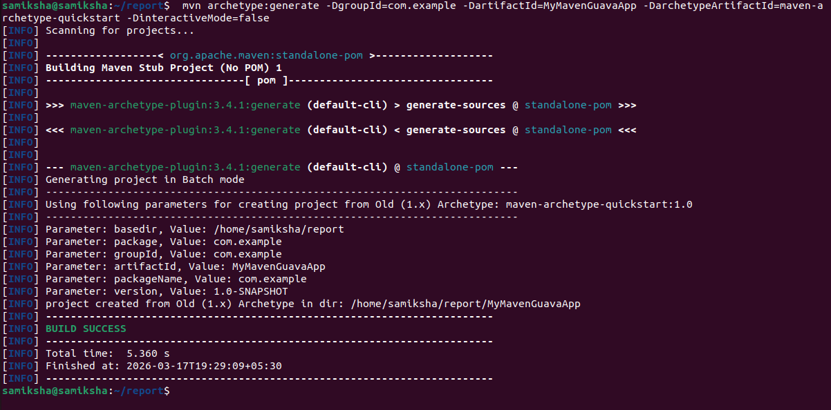
Now Navigate to the Project Directory using cd MyMavenGuavaApp

Edit the pom.xml File and add the code
<project xmlns="http://maven.apache.org/POM/4.0.0" xmlns:xsi="http://www.w3.org/2001/XMLSchema-instance"
xsi:schemaLocation="http://maven.apache.org/POM/4.0.0 http://maven.apache.org/maven-v4_0_0.xsd">
<modelVersion>4.0.0</modelVersion>
<groupId>com.example</groupId>
<artifactId>MyMavenGuavaApp</artifactId>
<packaging>jar</packaging>
<version>1.0-SNAPSHOT</version>
<name>MyMavenGuavaApp</name>
<url>http://maven.apache.org</url>
<dependencies>
<dependency>
<groupId>junit</groupId>
<artifactId>junit</artifactId>
<version>3.8.1</version>
<scope>test</scope>
</dependency>

<!-- https://mvnrepository.com/artifact/com.google.guava/guava -->
<dependency>
<groupId>com.google.guava</groupId>
<artifactId>guava</artifactId>
<version>33.4.0-jre</version>
</dependency>

<!-- https://mvnrepository.com/artifact/commons-io/commons-io -->
<dependency>
<groupId>commons-io</groupId>
<artifactId>commons-io</artifactId>
<version>2.18.0</version>
</dependency>

</dependencies>

<!-- Build: Configuring plugins and build settings -->
<build>
<plugins>
<!-- Example: Maven Compiler Plugin to compile Java code -->
<plugin>
<groupId>org.apache.maven.plugins</groupId>
<artifactId>maven-compiler-plugin</artifactId>
<version>3.8.1</version>
<configuration>
<source>1.7</source>
<target>1.7</target>
</configuration>
</plugin>

<!-- Example: Maven Surefire Plugin to run tests -->
<plugin>
<groupId>org.apache.maven.plugins</groupId>
<artifactId>maven-surefire-plugin</artifactId>
<version>2.22.2</version>
</plugin>

<plugin>
<groupId>org.apache.maven.plugins</groupId>
<artifactId>maven-jar-plugin</artifactId>
<version>3.1.0</version>
<configuration>
<archive>
<manifestEntries>
<Main-Class>com.example.App</Main-Class>
</manifestEntries>
</archive>
</configuration>
</plugin>

</plugins>
</build>
</project>

Modify App.java
Got to App.java using cd src/main/java/com/example/ and gedit App.java to type the file with following code:
package com.example;

/**
* Hello world!
*
*/
// Import FileUtils class from Apache Commons IO library
// This is used to perform file operations like copying files
import org.apache.commons.io.FileUtils;

// Import File class to represent file and directory pathnames
import java.io.File;

// Import IOException to handle input-output errors
import java.io.IOException;

// Import ImmutableList from Google Guava library
// ImmutableList creates a list that cannot be modified after creation
import com.google.common.collect.ImmutableList;

// Define the main class
public class App
{
// Main method - program execution starts from here
public static void main( String[] args )
{
// Create an immutable list of strings (fruits)
// This list cannot be changed (no add/remove allowed)
ImmutableList<String> fruits = ImmutableList.of("Apple", "Banana", "Cherry");

// Print the list of fruits to the console
System.out.println(fruits);

// Create a File object representing the source file
File sourceFile = new File("source.txt");

// Create a File object representing the destination file
File destFile = new File("destination.txt");

try {
// Copy the contents of source.txt to destination.txt
// Using Apache Commons IO FileUtils class
FileUtils.copyFile(sourceFile, destFile);

// Print success message if file is copied
System.out.println("File copied successfully!");
}
catch (IOException e) {
// If any error occurs during file copying,
// this block will handle the exception
// Print error message
System.err.println("Error occurred while copying file: " + e.getMessage());
}
}
}
Build the Project using the command mvn clean install command

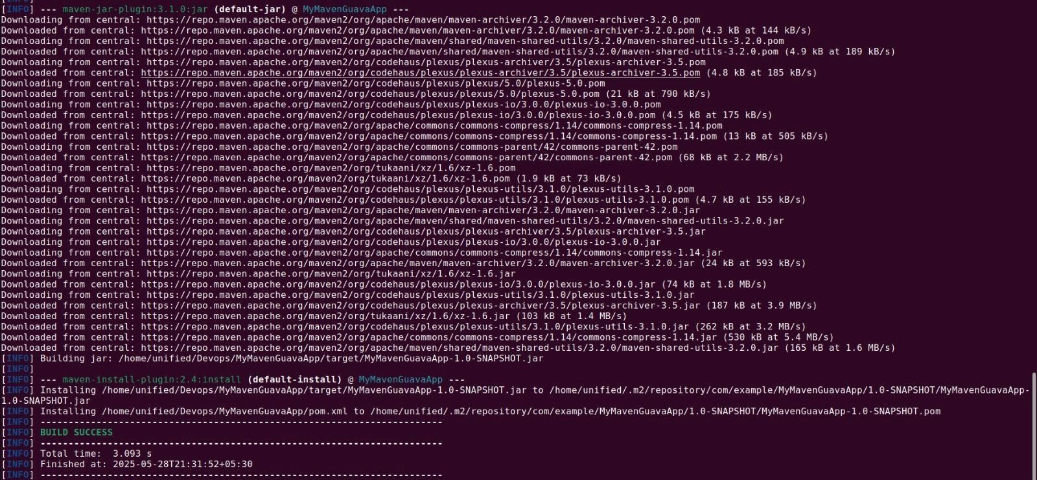

This compiles the project and creates a JAR in the target/ folder.
Run the Application:
If java-jar command give an error which is most probable, use the following command mvn exec:java -Dexec.mainClass=”com.example.App”
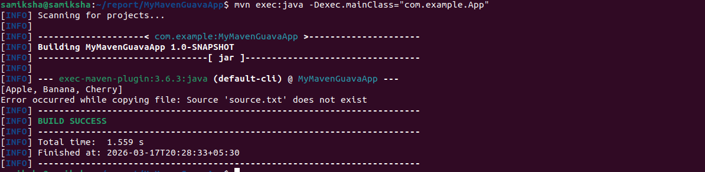
This command gives error as
Error while copying file:Source ‘source.txt’ does not exist
Now, Create a Sample File to copy the content to destination file
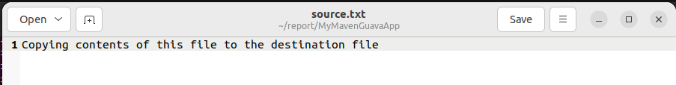

Now Run the command mvn exec:java -Dexec.mainClass=”com.example.App” again
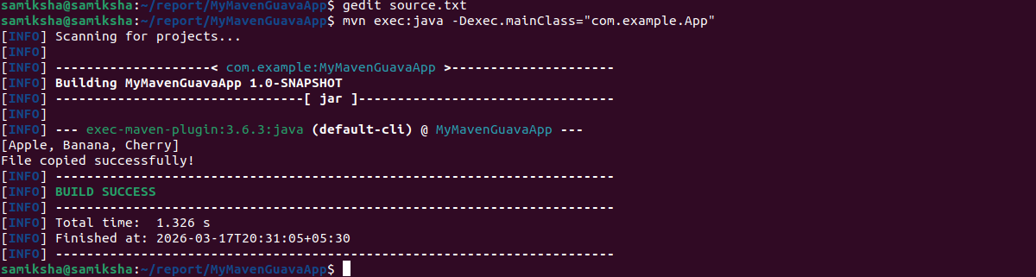

The output shows file copied successfully.
We can see newly created destination.txt using gedit destination.txt if you are still in Project’s directory
File content is same as the content in source file.

Program 3: Working with Selenium: Maven Project To Connect To Web Servers Using Selenium Dependency
1.Sauce.demo webpage
Step 1: create a maven project on terminal by typing the command mvn archetype:generate -DgroupId=com.example -DartifactId=MyMavenSeleniumApp01 -DarchetypeArtifactiId=maven-archetype-quickstart -DinteractiveMode=false
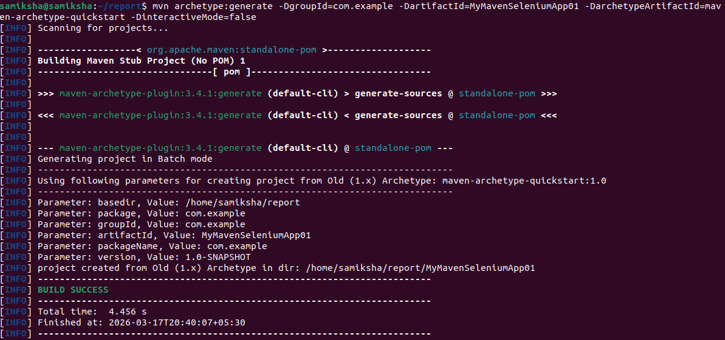

Step 2: Before we connect to web servers we need to have chrome driver installed. To download chrome driver
To check the chrome version type the command google-chrome –version in the terminal
extract the version and store it in a variable CHROME_VERSION
extracts and transorms JSON data
LATEST_DRIVER=$(curl -s "https://googlechromelabs.github.io/chrome-for-testing/latest-patch-versions-per-build.json" | jq -r ".builds[\"$CHROME_VERSION\"].version")
do install curl using the command
sudo apt install curl
wget https://storage.googleapis.com/chrome-for-testing-public/$LATEST_DRIVER/linux64/chromedriver-linux64.zip

Extract and move it to /usr/local/bin/:

unzip chromedriver-linux64.zip
sudo mv chromedriver-linux64/chromedriver /usr/local/bin/chromedriver
sudo chmod +x /usr/local/bin/chromedriver
Check if ChromeDriver is installed correctly:
Step 3 : edit the pom.xml file and add the dependencies
The pom.xml has the code

<project xmlns="http://maven.apache.org/POM/4.0.0" xmlns:xsi="http://www.w3.org/2001/XMLSchema-instance"
xsi:schemaLocation="http://maven.apache.org/POM/4.0.0 http://maven.apache.org/maven-v4_0_0.xsd">
<modelVersion>4.0.0</modelVersion>
<groupId>com.example</groupId>
<artifactId>MyMavenSeleniumApp01</artifactId>
<packaging>jar</packagi<ng>
<version>1.0-SNAPSHOT</version>
<name>MyMavenSeleniumApp01</name>
<url>http://maven.apache.org</url>
<dependencies>
<dependency>
<groupId>junit</groupId>
<artifactId>junit</artifactId>
<version>3.8.1</version>
<scope>test</scope>
</dependency>
<!-- https://mvnrepository.com/artifact/org.seleniumhq.selenium/selenium-java -->
<dependency>
<groupId>org.seleniumhq.selenium</groupId>
<artifactId>selenium-java</artifactId>
<version>4.29.0</version>
</dependency>
</dependencies>
<!-- Build: Configuring plugins and build settings -->
<build>
<plugins>
<!-- Example: Maven Compiler Plugin to compile Java code -->
<plugin>
<groupId>org.apache.maven.plugins</groupId>
<artifactId>maven-compiler-plugin</artifactId>
<version>3.8.1</version>
<configuration>
<source>1.7</source>
<target>1.7</target>
</configuration>
</plugin>
<!-- Example: Maven Surefire Plugin to run tests -->
<plugin>
<groupId>org.apache.maven.plugins</groupId>
<artifactId>maven-surefire-plugin</artifactId>
<version>2.22.2</version>
</plugin>
<plugin>
<groupId>org.apache.maven.plugins</groupId>

<artifactId>maven-jar-plugin</artifactId>
<version>3.0.1</version>
<configuration>
<archive>
<manifestEntries>
<Main-Class>com.example.App</Main-Class>
</manifestEntries>
</archive>
</configuration>

</plugin>

</plugins>
</build>
</project>
Step 4: Edit the App.java
package com.example;

import org.openqa.selenium.By;
import org.openqa.selenium.WebDriver;
import org.openqa.selenium.chrome.ChromeDriver;

/**
* Hello world!
*
*/
public class App
{
public static void main( String[] args )
{
WebDriver driver=new ChromeDriver();
driver.get("https://www.saucedemo.com/");
driver.manage().window().maximize();
driver.findElement(By.id("user-name")).sendKeys("standard_user");
driver.findElement(By.id("password")).sendKeys("secret_sauce");
driver.findElement(By.id("login-button")).click();
}
}

Step 5:build and run the maven application
Type mvn clean install in the terminal
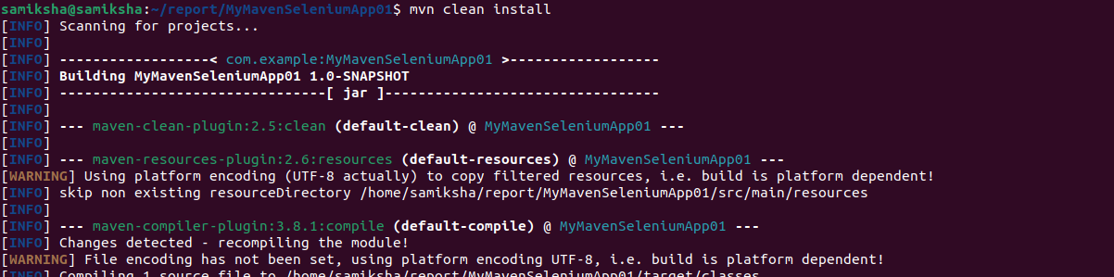
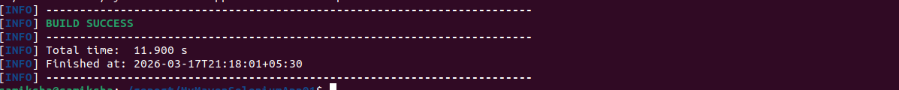

To execute type the command mvn exec:java -Dexec.mainClass="com.example.App"
it opens saucedemo.com and we can login using the credentials
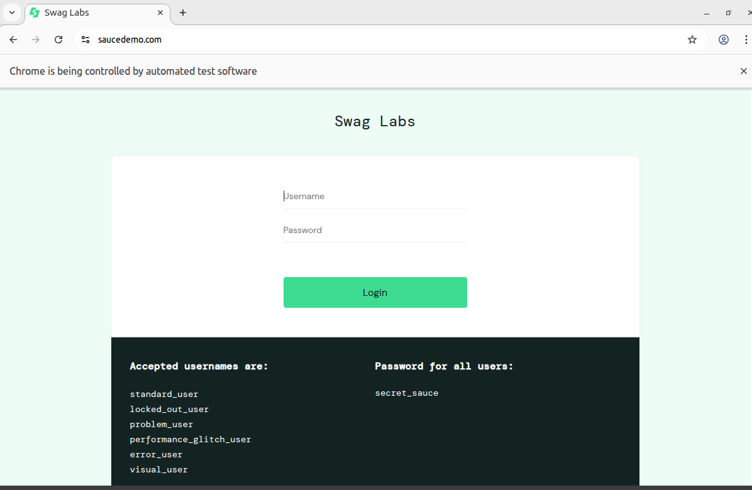

2. practiceautomation.com
Step 1: create a maven project on terminal by typing the command mvn archetype:generate -DgroupId=com.example -DartifactId=MyMavenPracticeAutomation -DarchetypeArtifactiId=maven-archetype-quickstart -DinteractiveMode=false

Step 2 : edit the pom.xml file and add the dependencies
The pom.xml has the code
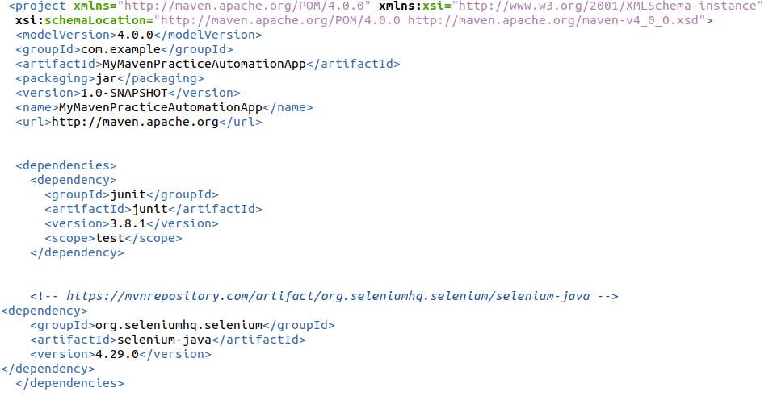
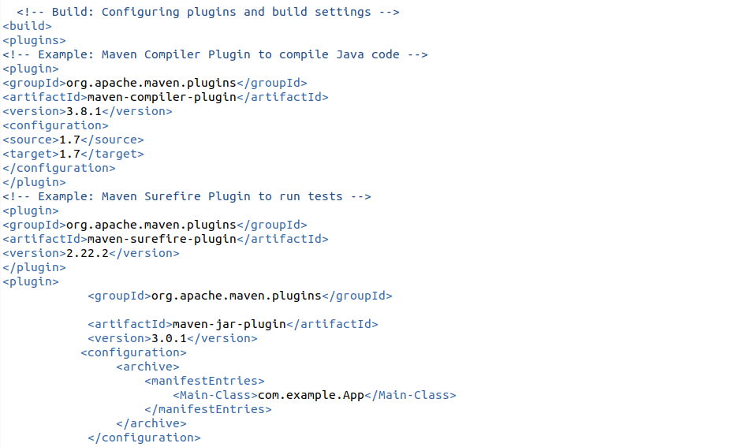
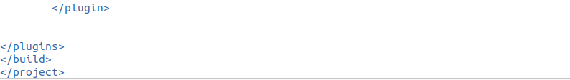

Step 3: Edit the App.java
package com.example;
import org.openqa.selenium.By;
import org.openqa.selenium.WebDriver;
import org.openqa.selenium.chrome.ChromeDriver;
public class App
{
public static void main( String[] args )
{
WebDriver driver = new ChromeDriver();
driver.get("https://practicetestautomation.com/practice-test-login/");
driver.manage().window().maximize();
driver.findElement(By.id("username")).sendKeys("student");
driver.findElement(By.id("password")).sendKeys("Password123");
driver.findElement(By.id("submit")).click();
}
}
Step 4:build and run the maven application
To execute type the command mvn exec:java -Dexec.mainClass="com.example.App"
it openspracticeautomation.com and we can login using the credentials
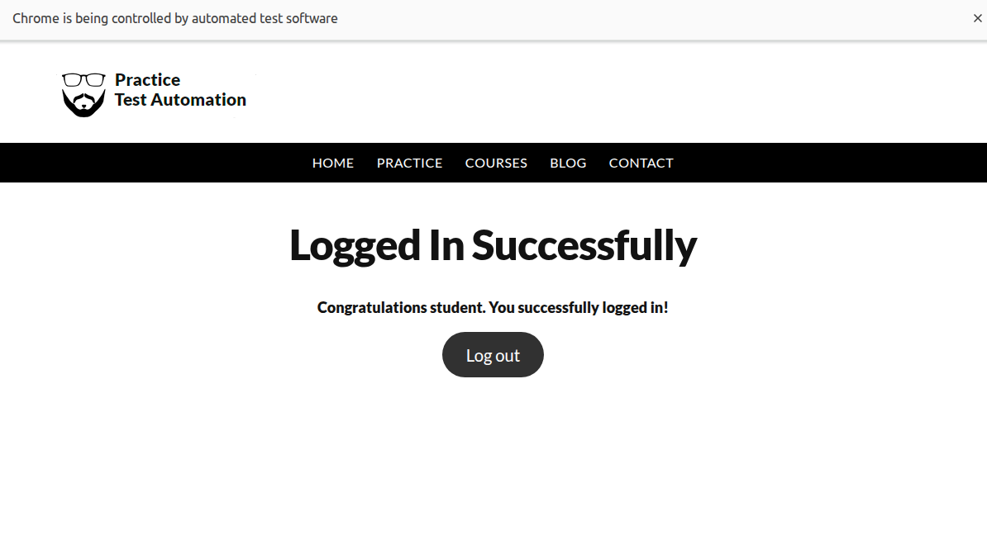

3.automationexercise.com
Step 1: create a maven project on terminal by typing the command mvn archetype:generate -DgroupId=com.example -DartifactId=MyMavenAutomationExercise -DarchetypeArtifactiId=maven-archetype-quickstart -DinteractiveMode=false

Step 2 : edit the pom.xml file and add the dependencies
The pom.xml has the code
<project xmlns="http://maven.apache.org/POM/4.0.0" xmlns:xsi="http://www.w3.org/2001/XMLSchema-instance"
xsi:schemaLocation="http://maven.apache.org/POM/4.0.0 http://maven.apache.org/maven-v4_0_0.xsd">

<modelVersion>4.0.0</modelVersion>
<groupId>com.example</groupId>
<artifactId>MyMavenExerciseAutomationApp</artifactId>
<packaging>jar</packaging>
<version>1.0-SNAPSHOT</version>
<name>MyMavenExerciseAutomationApp</name>
<url>http://maven.apache.org</url>

<dependencies>
<dependency>
<groupId>junit</groupId>
<artifactId>junit</artifactId>
<version>3.8.1</version>
<scope>test</scope>
</dependency>

<!-- https://mvnrepository.com/artifact/org.seleniumhq.selenium/selenium-java -->
<dependency>
<groupId>org.seleniumhq.selenium</groupId>
<artifactId>selenium-java</artifactId>
<version>4.29.0</version>
</dependency>

<dependency>
<groupId>io.github.bonigarcia</groupId>
<artifactId>webdrivermanager</artifactId>
<version>5.8.0</version>
</dependency>
</dependencies>
<!-- Build: Configuring plugins and build settings -->
<build>
<plugins>
<!-- Example: Maven Compiler Plugin to compile Java code -->
<plugin>
<groupId>org.apache.maven.plugins</groupId>
<artifactId>maven-compiler-plugin</artifactId>
<version>3.8.1</version>
<configuration>
<source>1.7</source>
<target>1.7</target>
</configuration>
</plugin>
<!-- Example: Maven Surefire Plugin to run tests -->
<plugin>
<groupId>org.apache.maven.plugins</groupId>
<artifactId>maven-surefire-plugin</artifactId>
<version>2.22.2</version>
</plugin>
<plugin>
<groupId>org.apache.maven.plugins</groupId>

<artifactId>maven-jar-plugin</artifactId>
<version>3.0.1</version>
<configuration>
<archive>
<manifestEntries>
<Main-Class>com.example.App</Main-Class>
</manifestEntries>
</archive>
</configuration>
</plugin>
</plugins>
</build>
</project>

Step 3: Edit the App.java
package com.example;

import org.openqa.selenium.By;
import org.openqa.selenium.WebDriver;
import org.openqa.selenium.WebElement;
import org.openqa.selenium.chrome.ChromeDriver;
import org.openqa.selenium.JavascriptExecutor;
import org.openqa.selenium.support.ui.WebDriverWait;
import org.openqa.selenium.support.ui.ExpectedConditions;

import io.github.bonigarcia.wdm.WebDriverManager;
import java.time.Duration;

public class App {
public static void main(String[] args) {

WebDriverManager.chromedriver().setup();
WebDriver driver = new ChromeDriver();
driver.manage().window().maximize();

WebDriverWait wait = new WebDriverWait(driver, Duration.ofSeconds(10));

try {
driver.get("https://automationexercise.com");

// Click Products page
wait.until(ExpectedConditions.elementToBeClickable(By.xpath("//a[@href='/products']"))).click();

// Find first Add to Cart button
WebElement addToCart = wait.until(ExpectedConditions.elementToBeClickable(
By.xpath("//a[@data-product-id='1']")));

// Scroll and click using JavaScript (avoids ad overlay)
((JavascriptExecutor) driver).executeScript("arguments[0].scrollIntoView(true);", addToCart);
((JavascriptExecutor) driver).executeScript("arguments[0].click();", addToCart);

// Wait for confirmation modal
wait.until(ExpectedConditions.visibilityOfElementLocated(By.id("cartModal")));

// Click View Cart
wait.until(ExpectedConditions.elementToBeClickable(By.linkText("View Cart"))).click();

System.out.println("Product successfully added to cart!");

} catch (Exception e) {
System.out.println("TEST FAILED: " + e.getMessage());
}

System.out.println("Browser will remain open for inspection.");
}
}

Step 4:build and run the maven application
To execute type the command mvn exec:java -Dexec.mainClass="com.example.App"
it opens automationexercise.com and automatically adds a product to cart
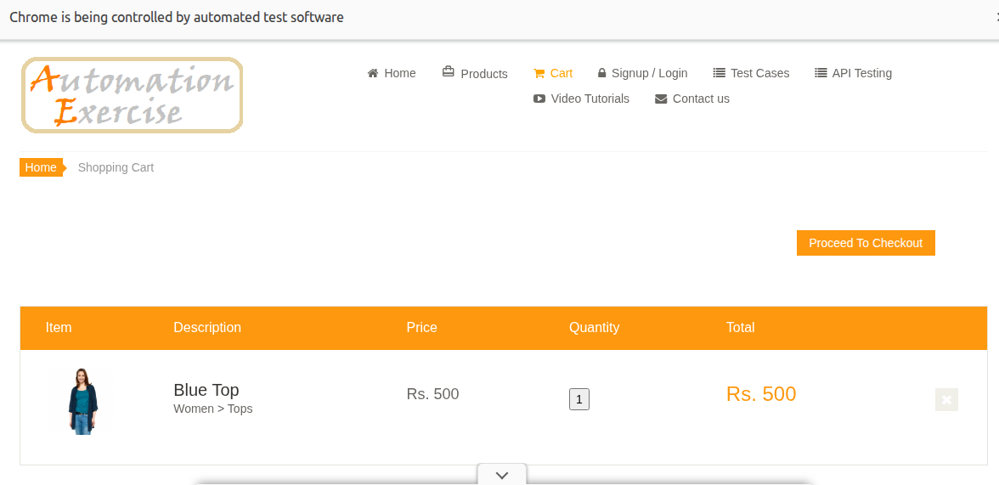

4. All 3 exercises executed using firefox
Step 1: create a maven project on terminal by typing the command mvn archetype:generate -DgroupId=com.example -DartifactId=MyMavenFireFox -DarchetypeArtifactiId=maven-archetype-quickstart -DinteractiveMode=false
Step 2 : edit the pom.xml file and add the dependencies
The pom.xml has the code
<project xmlns="http://maven.apache.org/POM/4.0.0"
xmlns:xsi="http://www.w3.org/2001/XMLSchema-instance"
xsi:schemaLocation="http://maven.apache.org/POM/4.0.0
http://maven.apache.org/xsd/maven-4.0.0.xsd">

<modelVersion>4.0.0</modelVersion>

<groupId>com.example</groupId>
<artifactId>MyMavenExerciseAutomationApp</artifactId>
<version>1.0-SNAPSHOT</version>
<packaging>jar</packaging>

<name>MyMavenExerciseAutomationApp</name>

<!-- Java Version -->
<properties>
<maven.compiler.source>17</maven.compiler.source>
<maven.compiler.target>17</maven.compiler.target>
</properties>

<dependencies>

<!-- Selenium -->
<dependency>
<groupId>org.seleniumhq.selenium</groupId>
<artifactId>selenium-java</artifactId>
<version>4.29.0</version>
</dependency>

<!-- WebDriverManager (handles GeckoDriver automatically) -->
<dependency>
<groupId>io.github.bonigarcia</groupId>
<artifactId>webdrivermanager</artifactId>
<version>5.8.0</version>
</dependency>

<!-- JUnit (optional, for testing) -->
<dependency>
<groupId>junit</groupId>
<artifactId>junit</artifactId>
<version>4.13.2</version>
<scope>test</scope>
</dependency>

</dependencies>

<build>
<plugins>

<!-- Compiler Plugin -->
<plugin>
<artifactId>maven-compiler-plugin</artifactId>
<version>3.11.0</version>
</plugin>

<!-- Exec Plugin (to run your main class) -->
<plugin>
<groupId>org.codehaus.mojo</groupId>
<artifactId>exec-maven-plugin</artifactId>
<version>3.1.0</version>
<configuration>
<mainClass>com.example.App</mainClass>
</configuration>
</plugin>

</plugins>
</build>

</project>
Step 3: Edit the App.java
package com.example;

import org.openqa.selenium.By;
import org.openqa.selenium.WebDriver;
import org.openqa.selenium.firefox.FirefoxDriver;

public class App {

public static void main(String[] args) {

WebDriver driver = new FirefoxDriver();

// ----------- 1. SauceDemo Login -----------
driver.get("https://www.saucedemo.com/");
driver.manage().window().maximize();

driver.findElement(By.id("user-name")).sendKeys("standard_user");
driver.findElement(By.id("password")).sendKeys("secret_sauce");
driver.findElement(By.id("login-button")).click();

// ----------- 2. Practice Test Login -----------
driver.get("https://practicetestautomation.com/practice-test-login/");
driver.manage().window().maximize();

driver.findElement(By.id("username")).sendKeys("student");
driver.findElement(By.id("password")).sendKeys("Password123");
driver.findElement(By.id("submit")).click();

// ----------- 3. Automation Exercise Search -----------
driver.get("https://automationexercise.com/products");
driver.manage().window().maximize();

driver.findElement(By.id("search_product")).sendKeys("Blue Top");
driver.findElement(By.id("submit_search")).click();

// driver.quit(); // optional
}
Step 4:build and run the maven application
To execute type the command mvn exec:java -Dexec.mainClass="com.example.App"
This executes all the three exercises together.
